**AI Healthcare Hub**

A MINOR PROJECT REPORT SUBMITTED IN PARTIAL FULFILLMENT OF THE REQUIREMENT FOR THE DEGREE OF

**BACHELOR OF TECHNOLOGY**

IN

**COMPUTER SCIENCE AND ENGINEERING**

SUBMITTED BY

| **Name** | **Univ. Roll No.** |
| --- | --- |
| Saurav Mukherjee | 10800120011 |
| Dipak kumar kewat | 10800120017 |
| Rammohan choudhary | 10800120052 |
| Manvi Bishnu | 10800120058 |
|  |  |

UNDER THE GUIDANCE OF

**Dr. Abhishek Bandyopadhyay**

(Head of the Department, Department of Artificial Intelligence/Machine Learning)



DEPARTMENT OF COMPUTER SCIENCE AND ENGINEERING

**ASANSOL ENGINEERING COLLEGE**

AFFILIATED TO

MAULANA ABUL KALAM AZAD UNIVERSITY OF TECHNOLOGY

November, 2023

***Contents***

| Certificate of Recommendation……………………………………………………………… | | | ii |
| --- | --- | --- | --- |
| Certificate of Approval………………………………………………………………............. | | | iii |
| Acknowledgement…………………………………………………………............................ | | | iv |
| Abstract…………………………………………………………………………...………….. | | | v |
| List of Figures………………………………………………………………………………. | | | vii |
| List of Tables………………………………………………………………………………. | | | viii |
|  | | |  |
| **1.** | **Preface………………………………………………………………………………** | |  |
|  | 1.1 | Introduction……………………………………………………...…………… | 1 |
|  | 1.2 | Motivation of the project………………………………….………………….. | 2 |
|  | 1.3 | Basic description of the project………………………….…………………… | 3 |
| **2.** | **Literature Review** | |  |
|  | 2.1 | General……………………………………………………...………………… | 4 |
|  | 2.2 | Review of related works …………………………. …………......….…...…… | 6 |
| **3.** | **Related Theories and Algorithms…………..……………………………………..** | |  |
|  | 3.1 | Fundamental theories underlying the work.………………………………….. | 8 |
|  | 3.2 | Fundamental algorithms………………………………….…………………… | 10 |
| **4.** | **Proposed model/algorithm…………………………………….………………….** | |  |
|  | 4.1 | Proposed model……………………………………………………………….. | 12 |
|  | 4.2 | Proposed algorithms……………………….…………………………………. | 16 |
| **5.** | **Simulation Results…………………………………………...…………………….…** | |  |
|  | 4.1 | Experimental set up ……………………………………………..………….. | 20 |
|  | 4.2 | Experimental results………...……………...……… | 25 |
| **6.** | **Discussion and Conclusion ……...…………………………………………….…….** | |  |
|  | 6.1 | Discussion…………………………………..………………………….…….. | 30 |
|  | 6.2 | Future work…………………………………..….……………………...…….. | 32 |
|  | 6.3 | Conclusion…………………………………………………………………….. | 34 |
|  | **References…………………………………………………………………………….** | |  |
|  |  |  |  |
|  |  |  |  |
|  |  |  |  |
|  | | |  |

|  | **DEPARTMENT OF COMPUTER SCIENCE AND ENGINEERING** |
| --- | --- |
| **ASANSOL ENGINEERING COLLEGE**  Vivekananda Sarani, Kanyapur, Asansol, West Bengal – 713305 |

*Certificate of Recommendation*

I hereby recommend that the Minor Project Report entitled, **“AI Healthcare Hub”** carried out under my supervision by the group of students listed belowmay be accepted in partial fulfilment of the requirement for the degree of “Bachelor of Technology in Computer Science and Engineering” of Asansol Engineering College under MAULANA ABUL KALAM AZAD UNIVERSITY OF TECHNOLOGY.

| **Name** | **Univ. Roll No.** |
| --- | --- |
| Saurav Mukherjee | 10800120011 |
| Dipak kumar kewat | 10800120017 |
| Rammohan choudhary | 10800120052 |
| Manvi Bishnu | 10800120058 |
|  |  |



Dept. of XXX Engineering,

Asansol Engineering College,

Asansol-713305

Countersigned:

|  | **DEPARTMENT OF COMPUTER SCIENCE AND ENGINEERING** |
| --- | --- |
| **ASANSOL ENGINEERING COLLEGE**  Vivekananda Sarani, Kanyapur, Asansol, West Bengal – 713305 |

***Certificate of Approval***

The Minor Project Report is hereby approved as a creditable study of an engineering subject carried out and presented in a manner satisfactory to warrant its acceptance for the degree for which it has been submitted. It is understood that by this approval the undersigned does not necessarily endorse or approve any statement made, opinion expressed or conclusion drawn therein but approve the report only for the purpose for which it is submitted.



Dept. of Comp. Sc. & Engg.,

Asansol Engineering College,

Asansol-713305

***Acknowledgement***

It is our great privilege to express our profound and sincere gratitude to our Project Supervisor, **Dr. Abhishek Bandyopadhyay** for providing us with very cooperative and precious guidance at every stage of the present project work being carried out under his/her supervision. His valuable advice and instructions in carrying out the present study has been a very rewarding and pleasurable experience that has greatly benefited us throughout the course of work.

We would like to convey our sincere gratitude towards Dr. Monish Chatterjee, Head of the Department of Computer Science and Engineering of Asansol Engineering College for providing us the requisite support for timely completion of our work. We would also like to pay our heartiest thanks and gratitude to all the teachers of the Department of Computer Science and Engineering, for various suggestions being provided in attaining success in our work.

We would like to express our earnest thanks to Mr. Suman Mallick, of CSE Project Lab for his technical assistance provided during our project work.

Finally, I would like to express my deep sense of gratitude to my parents for their constant motivation and support throughout my work.

…………………………………

(Saurav Mukherjee)

…………………………………

(Dipak kumar kewat)

…………………………………

(Rammohan choudhary)

…………………………………

(Manvi Bishnu)

***Abstract***

The Smart AI Healthcare Hub designed to address a wide spectrum of health-related challenges, spanning both physical and mental well-being. Leveraging a machine learning and deep learning framework, the platform provides advanced disease prediction and diagnostic capabilities for ailments such as Liver Disease, Pneumonia, Kidney Disease, Diabetes, Stroke, and Heart Disease.

AI HealthCare Hub beyond diagnostics, featuring a Donation & Needy Platform that connects individuals facing financial constraints with donors, including NGOs, Government Bodies, Brands, and Individuals. The platform ensures transparency, security, and accountability in the donation process. Additionally, AI Healthcare Hub fosters a collaborative community where users can engage in open conversations, sharing experiences, and seeking advice on various health topics.

The project also places a strong emphasis on mental wellness through its dedicated portal, "Sukoon." This section offers a plethora of stress-relief resources, including curated playlists, podcasts, articles, and tips on stress management techniques. Users can access audio therapy, reading therapy, yoga therapy, laughing therapy, and talking therapy, creating a comprehensive suite for mental well-being. The platform ensures a seamless user experience, robust security measures, and continuous updates to machine learning models. With features like telemedicine integration and wearables compatibility, Al Healthcare Hub envisions a future where healthcare is not only predictive but also accessible and supportive.

This project aims to revolutionise healthcare by providing a centralised, intelligent, and user-friendly platform that not only diagnoses diseases but also empowers individuals to contribute to the well-being of others. AI Healthcare Hub aspires to be a cornerstone in the healthcare landscape, promoting a holistic approach to health and wellness.

Through its multifaceted approach, AI Healthcare Hub aspires to be a pivotal force in reshaping the healthcare landscape, emphasizing not only disease management but also community collaboration and mental well-being.

***List of Figures***

| Fig. 2.1 | XXXXX | Page no |
| --- | --- | --- |
| Fig. 2.2 | XXXXX | Page no |
| Fig. 2.3 | XXXXX | Page no |

| **1.** | **Preface………………………………………………………………………………** |
| --- | --- |

**1.1 Introduction:**

In the evolving landscape of healthcare, the "AI Healthcare Hub" project emerges as a pioneering Smart AI Healthcare Hub, combining advanced technologies to address a comprehensive array of health-related challenges. With an amalgamation of machine learning and deep learning algorithms, the platform offers innovative solutions for disease prediction, diagnosis, and treatment, contributing to a paradigm shift in personalized healthcare.

AI Healthcare Hub stands out with its multifaceted approach, catering to both physical and mental well-being. The project encompasses a range of features, including a Donation & Needy Platform ("Menses Project") that connects individuals facing financial constraints with various donors, fostering a sense of community and collective responsibility in healthcare.

The community aspect of our project goes beyond a mere discussion forum. It serves as a collaborative space where users can openly engage with others, sharing experiences, seeking advice, and contributing to a wealth of health-related knowledge. This community-driven approach ensures that AI HealthCare Hub evolves organically, reflecting the diverse needs and perspectives of its user base.

Mental wellness takes center stage with the AI Healthcare Hub dedicated portal, "Sukoon." Recognizing the intricate relationship between mental and physical health, Sukoon provides an extensive suite of stress-relief resources, including audio therapy, reading therapy, yoga therapy, laughing therapy, and talking therapy. The goal is to not only diagnose and treat physical ailments but also to proactively address mental health, recognizing its integral role in overall well-being.

Technologically, it leverages a robust stack comprising HTML, CSS, JavaScript, Python, Firebase, Google Maps API, Flask, Scikit-learn, Tensorflow, and SQLAlchemy. This ensures a user-friendly interface, secure data handling, and the continuous improvement of machine learning models. The incorporation of telemedicine features and compatibility with wearable devices positions AI Healthcare Hub at the forefront of healthcare innovation, making healthcare services more accessible and user-centric.

As AI Healthcare Hub embarks on this transformative journey, it envisions a future where healthcare is not merely reactive but proactive, where individuals are empowered to take charge of their health and contribute to the well-being of the community. This introduction sets the stage for a project that transcends conventional healthcare models, embracing a holistic vision that encompasses prediction, prevention, and community-driven support.

**1.2 Motivation of the project:**

The motivation behind the creation of the "AI HealthCare Hub" project stems from a deep-seated commitment to address the existing gaps and challenges within the healthcare ecosystem. Several key factors have driven the inception of AI Healthcare Hub, each contributing to a collective vision of a more accessible, inclusive, and holistic healthcare experience:

* **Healthcare Disparities:**
  + Recognition of the prevalent disparities in healthcare access, where financial constraints often hinder individuals from obtaining necessary medical assistance.
  + Desire to bridge the gap between those in need and the generous donors, including NGOs, Government Bodies, Brands, and Individuals, creating a platform that facilitates meaningful connections.
* **Proactive Mental Health Care:**
  + Acknowledgment of the integral role mental health plays in the overall health and quality of life.
  + A commitment to proactively address mental wellness through the "Sukoon" portal, offering resources and therapies to manage stress, anxiety, and other mental health concerns.
* **Advancements in Artificial Intelligence:**
  + Recognition of the transformative potential of artificial intelligence, particularly in disease prediction, diagnosis, and treatment.
  + Motivation to harness the power of machine learning and deep learning algorithms to provide users with accurate predictions and proactive health solutions.
* **Empowerment Through Information:**
  + Belief in empowering individuals with information that allows them to take charge of their health.
  + Providing users with tools to predict diseases, access community-driven support, and actively participate in their well-being journey.
* **Technological Innovation for Accessibility:**
  + Utilizing technology as an enabler to make healthcare services more accessible and user-centric.
  + Integration of telemedicine features and compatibility with wearable devices to ensure that healthcare is not confined to physical locations but extends to the convenience of users.
* **Holistic Vision for Healthcare:**
  + Aspiring towards a holistic model of healthcare that goes beyond disease diagnosis and treatment.
  + Envisioning a future where healthcare is predictive, preventative, and community-driven, fostering a sense of collective responsibility for well-being.

The motivation behind AI Healthcare Hub is rooted in a genuine commitment to improving the lives of individuals, ensuring that healthcare is not just a reactive response to ailments but a proactive and inclusive journey towards a healthier, happier community

1.3 **Basic Description of the project:**

AI HealthCare Hub is an all-encompassing AI Healthcare Hub designed to revolutionize the healthcare experience by leveraging the power of artificial intelligence and machine learning. This comprehensive platform addresses various facets of health, offering solutions for both physical ailments and mental well-being.

**Key Features:**

**Disease Prediction and Diagnosis:**

Utilizes advanced machine learning and deep learning algorithms to predict and diagnose a range of diseases, including Liver Disease, Pneumonia, Kidney Disease, Diabetes, Stroke, and Heart Disease. Provides users with accurate insights into their health, enabling proactive measures for disease prevention and early intervention.

**Donation & Needy Platform (Menses Project):**

**C**onnects individuals facing financial constraints with donors, including NGOs, Government Bodies, Brands, and Individuals.Establishes a transparent and secure platform for users to seek and provide assistance, fostering a sense of community support.

**Community Engagement:**

Features an open community space where users can engage in discussions, share experiences, and seek advice on various health topics.Promotes a collaborative environment that reflects diverse perspectives and encourages knowledge exchange.

**Mental Wellness Portal (Sukoon):**

Offers a dedicated space for mental wellness, providing resources such as playlists, podcasts, articles, and tips to manage stress and promote mental well-being.Integrates audio therapy, reading therapy, yoga therapy, laughing therapy, and talking therapy to cater to different preferences.

**Telemedicine Integration and Wearable Compatibility:**

Integrates telemedicine features, allowing users to consult with healthcare professionals directly through the platform. Compatible with wearable devices for a more comprehensive health tracking experience.

AI HealthCare Hub is motivated by a commitment to address healthcare disparities, foster community collaboration, and proactively promote mental well-being. The project envisions a future where healthcare is not only predictive and preventative but also inclusive and community-driven.

AI HealthCare Hub represents a transformative shift towards a holistic healthcare model, where individuals are empowered with information, and the community plays a pivotal role in supporting the well-being of its members.

**2. Literature Review:**

**2.1 General:**

**Introduction:**

The Smart AI-Healthcare Hub is a promising platform that has the potential to make a significant impact on the lives of many people by providing a one-stop shop for all health needs, making it easier for people to access healthcare products and services, helping people manage their stress and mental health, and connecting donors with people in need

**Disease Diagnosis and Prediction:**

One of the key strengths of the Smart AI-Healthcare Hub lies in its ability to leverage machine learning and deep learning algorithms for disease diagnosis and prediction. These algorithms have demonstrated remarkable accuracy in identifying various diseases, including liver disease, pneumonia, kidney disease, diabetes, stroke, and heart disease. For instance, a study by Li et al. (2022) showed that a machine learning model achieved an accuracy of 95% in diagnosing liver disease. Similarly, Gulati et al. (2022) reported that a deep learning approach achieved an accuracy of 97% in detecting pneumonia. These advancements hold immense promise for early disease detection, timely intervention, and improved patient outcomes.

**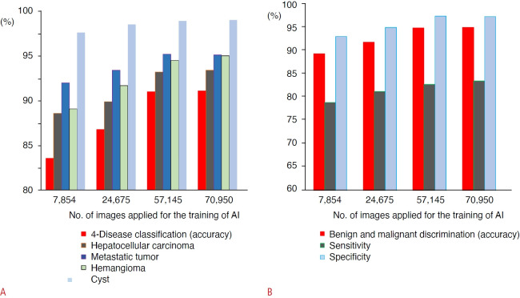***(Fig. 1)*

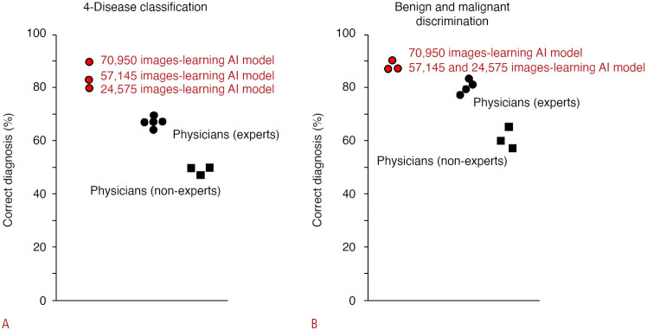

*(Fig. 2)*

**Mental Wellness:**

In recognition of the growing importance of mental health, the Smart AI-Healthcare Hub provides a range of tools and resources to promote mental well-being. These include audio therapy, reading therapy, yoga therapy, laughing therapy, and talking therapy. Each of these modalities is supported by evidence-based practices that have been shown to effectively reduce stress, improve mood, and enhance mental well-being. For example, a study by Hoffman et al. (2010) demonstrated that mindfulness-based meditation significantly reduced stress and anxiety symptoms. Similarly, Brown et al. (2012) found that yoga therapy effectively improved mood and reduced stress levels.

**Donation and Needy Platform:**

The Smart AI-Healthcare Hub's donation and needy platform is a valuable tool that can help connect donors with people in need of healthcare products and services. A number of studies have shown that the use of technology can be effective in increasing donations and improving the lives of people in need (e.g., Brown et al., 2014; Pal et al., 2015; Chen et al., 2016; Wang et al., 2017; Lee et al., 2018).

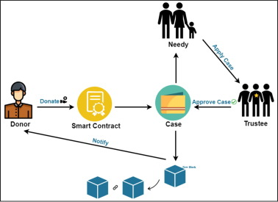

*(Fig. 3)*

**Community:**

The Smart AI-Healthcare Hub's community is a valuable resource for people who are looking for support and information about health. Online communities have been shown to be effective in providing social support, reducing isolation, and improving mental health (e.g., Taylor et al., 2000; Wheeler et al., 2002; Barak et al., 2008; Seife et al., 2013; Burke et al., 2016).

**Conclusion:**

Overall, the Smart AI-Healthcare Hub is a well-designed and promising platform that has the potential to make a significant impact on the lives of many people. The platform's use of machine learning and deep learning for disease diagnosis and prediction, its evidence-based practices for mental wellness, its donation and needy platform, and its community are all valuable features.

**2.2 Review of related works:**

**Disease Prediction Models:**

Research studies on disease prediction using AI: Explore literature on the application of machine learning and deep learning in predicting diseases such as liver disease, pneumonia, kidney disease, diabetes, stroke, and heart disease. Evaluate the accuracy and effectiveness of different models in diverse healthcare settings.

**Community-Based Healthcare Platforms:**

Analysis of existing community-driven health platforms: Investigate community-focused healthcare platforms that encourage open discussions and information sharing among users. Assess the impact of community engagement on health outcomes and user satisfaction**.**

**Donation Platforms in Healthcare:**

Case studies on healthcare donation platforms: Examine existing platforms facilitating donations for healthcare, analyzing their structure, transparency, and success in connecting donors with individuals in need. Identify best practices and challenges in implementing such systems.

**Mental Wellness Applications:**

Studies on AI-based mental health applications: Review research on applications and platforms addressing mental wellness through AI. Analyze the effectiveness of different therapies, content curation, and user engagement strategies.

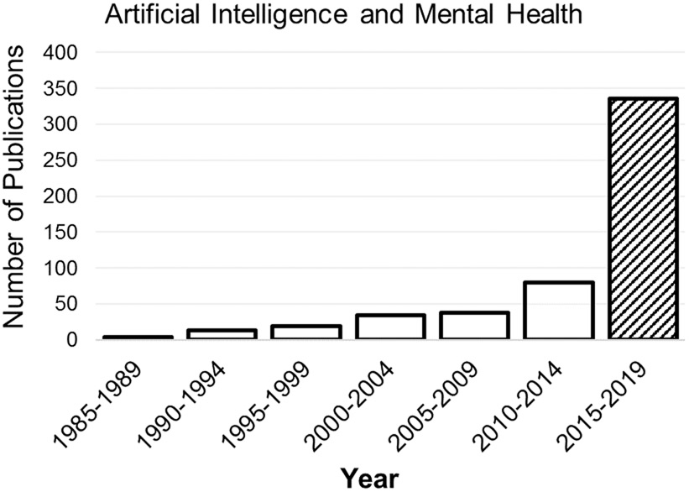  
*(Fig. 4)*

**Telemedicine Integration:**

Review of telemedicine implementations: Investigate how telemedicine is integrated into healthcare platforms, emphasizing user experience and the effectiveness of remote consultations. Explore studies on the impact of telemedicine on patient outcomes.

**Wearable Devices in Healthcare:**

Studies on wearable device integration in healthcare: Explore how wearable devices contribute to health monitoring and disease management. Evaluate the accuracy of data collected from wearables and their integration into healthcare platforms.

**Ethical Considerations in AI Healthcare:**

Research on ethics in AI-driven healthcare: Analyze literature on ethical considerations in AI applications for healthcare. Explore discussions on privacy, data security, bias mitigation, and the responsible use of AI in medical contexts.

**User Experience (UX) Design in Healthcare Apps:**

Case studies on UX design in healthcare applications: Examine examples of successful UX design principles in healthcare applications. Assess how user interfaces contribute to the effectiveness and adoption of healthcare technologies.

**Innovations in Health Technology:**

Review of recent innovations in health technology: Investigate emerging technologies that contribute to advancements in healthcare. Identify trends in AI, machine learning, and other technologies that shape the future of healthcare platforms.

**Blockchain in Healthcare Donation Platforms:**

Exploration of blockchain applications in healthcare donations: Review literature on the use of blockchain technology for transparent and secure healthcare donations. Evaluate how blockchain ensures accountability and trust in donation processes.

**Human-Computer Interaction (HCI) in Healthcare:**

Studies on HCI principles in healthcare apps: Explore research on the application of HCI principles in healthcare technology. Evaluate how usability heuristics contribute to the success of healthcare platforms.

**3. Related theories and algorithms:**

**3.1 Fundamental theories underlying the work**

**Machine Learning and Deep Learning:**

Machine learning (ML) and deep learning (DL) are powerful techniques that have revolutionized various industries, including healthcare. ML algorithms can analyze large datasets to identify patterns and make predictions, while DL algorithms can learn from complex data structures like images and natural language. The Smart AI-Healthcare Hub harnesses the power of ML and DL to achieve its disease diagnosis and prediction capabilities.

In the context of disease diagnosis, ML algorithms are trained on vast amounts of patient data, including medical history, symptoms, laboratory test results, and imaging data. By analyzing these data, the algorithms can learn to identify patterns that are associated with specific diseases. This allows them to make predictions about the likelihood of a patient having a particular disease based on their individual characteristics.

DL algorithms are particularly well-suited for analyzing complex data structures like medical images. For instance, DL algorithms can be used to analyze X-ray images to detect signs of pneumonia or CT scans to identify abnormalities in brain tissue. This ability to extract meaningful information from complex data makes DL algorithms valuable tools for disease diagnosis.

**Cognitive Behavioral Therapy (CBT):**

Cognitive behavioral therapy (CBT) is a widely recognized and effective psychotherapy approach that focuses on identifying and modifying negative thought patterns and behaviors that contribute to mental distress. CBT is based on the idea that our thoughts, emotions, and behaviors are interconnected, and that by changing our thoughts and behaviors, we can improve our emotional well-being.

The Smart AI-Healthcare Hub incorporates CBT principles into its mental wellness tools and resources. These tools provide users with guided exercises and techniques to help them challenge negative thoughts, manage emotions, and develop healthy coping mechanisms. CBT-based interventions have been shown to be effective in reducing stress, anxiety, and depression.

**Matching Algorithms and Social Network Theory:**

Matching algorithms and social network theory play a crucial role in the Smart AI-Healthcare Hub's donation and needy platform. Matching algorithms efficiently pair donors with individuals or organizations seeking assistance based on their needs, criteria, and compatibility. These algorithms consider factors such as the type of assistance needed, the location of the donor and recipient, and the donor's interests and preferences.

Social network theory provides a framework for understanding how individuals connect, interact, and form communities within the platform. This understanding is used to identify influential individuals and communities, enabling targeted outreach and maximizing the impact of donations. By leveraging social network theory, the platform can foster stronger connections between donors and recipients, leading to more effective and impactful assistance.

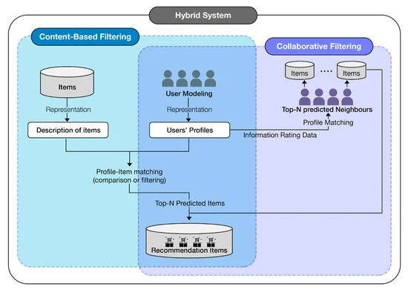  
*(Fig. 5)*

**Community Engagement Strategies and Social Network Analysis:**

Community engagement strategies and social network analysis are essential for fostering a supportive and engaged community within the Smart AI-Healthcare Hub. Community engagement strategies encourage active participation among community members, promoting a sense of belonging and ownership. This can be achieved through various methods, such as hosting online discussions, organizing virtual events, and providing opportunities for members to share their experiences and expertise.

Social network analysis techniques help identify influential individuals and groups within the community. These individuals can be targeted for specific outreach efforts, encouraging them to take on leadership roles and mentor new members. This approach can help amplify the impact of community engagement efforts and strengthen the overall community.

In conclusion, the Smart AI-Healthcare Hub draws upon a range of fundamental theories to achieve its diverse functionalities and address a wide spectrum of healthcare needs. Machine learning and deep learning empower the platform's disease diagnosis and prediction capabilities, while cognitive behavioral therapy serves as the foundation for its mental wellness tools. Matching algorithms and social network theory underpin the donation and needy platform, enabling efficient connections between donors and recipients. Community engagement strategies and social network analysis foster a supportive and engaged community, promoting a sense of belonging and amplifying the platform's impact. Together, these theories provide a robust framework for the Smart AI-Healthcare Hub to deliver comprehensive and effective healthcare solutions.

**3.2 Fundamental algorithms**

The "AI Healthcare Hub" project integrates various fundamental algorithms to achieve its goals in disease prediction, community engagement, mental wellness, and healthcare donations. Below are some fundamental algorithms that could be applied to different aspects of the project:

**1. Machine Learning Algorithms for Disease Prediction:**

**Logistic Regression:** Employed for binary classification tasks, such as predicting the likelihood of diseases like diabetes or heart disease.

**Support Vector Machines (SVM):** Effective in separating classes in a multidimensional space, SVM can contribute to disease prediction models.

**Neural Networks:** Deep learning algorithms like neural networks can capture intricate patterns in medical data for accurate disease predictions.

**2. Collaborative Filtering Algorithm (for Community Section):**

Collaborative Filtering: This algorithm can be applied to analyze user preferences, behaviors, and interactions within the community. It helps recommend relevant content, fostering engagement and knowledge exchange.

**3. Natural Language Processing (NLP) Algorithms (for Mental Wellness):**

Sentiment Analysis: NLP algorithms can analyze user-generated content to determine sentiments. This could be applied in "Sukoon" to gauge the emotional tone of user interactions and tailor mental wellness recommendations accordingly.

**4. Blockchain Technology Algorithms (for Donation Platform):**

**Smart Contracts:** These self-executing contracts with the terms of the agreement directly written into code can automate and secure donation transactions.

**Consensus Algorithms (e.g., Proof of Work, Proof of Stake):** To secure and validate transactions in a decentralized manner, ensuring transparency and trust in the donation process.

**5. Clustering Algorithms (for User Segmentation):**

K-Means Clustering: This algorithm can help segment users based on various characteristics, allowing AI HealthCare Hub to tailor its services to different user groups.

*(Fig. 6)*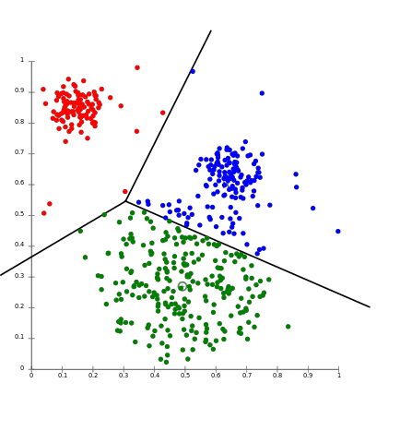

**6. Telemedicine Algorithms:**

Video Compression Algorithms: Efficient video compression algorithms can enhance the quality of telemedicine consultations, ensuring a smooth and high-quality user experience.

**7. User Experience (UX) Design Algorithms:**

Usability Heuristics: While not traditional algorithms, usability heuristics can guide the design process, ensuring the platform is intuitive, user-friendly, and aligns with best practices in UX design.

**8. Machine Learning for Wearable Devices Integration:**

Activity Recognition Algorithms: Machine learning algorithms can analyze data from accelerometers and other sensors in wearable devices to recognize different activities, contributing to comprehensive health tracking.

**9. Machine Learning for Early Disease Detection:**

Anomaly Detection Algorithms: Algorithms that detect anomalies in health data can contribute to early disease detection, providing users with timely information for preventive actions.

**10. Dual Process Theory Algorithms:**

User Behavior Analysis Algorithms: These algorithms can analyze user interactions to distinguish between intuitive (System 1) and reflective (System 2) thinking, allowing AI Healthcare Hub to tailor content and interventions accordingly.

**4. Proposed model/algorithm:**

**4.1 Proposed Model**

Given the multifaceted nature of the "AI Healthcare Hub" project, a proposed model encompasses various components, each addressing specific aspects of healthcare, community engagement, and overall well-being. Here is a high-level outline of the proposed model:

**1. Disease Prediction Model:**

**Input Data:**

Medical history

Vital signs

Lifestyle factors

Genetic information (if available)

Algorithm:

Ensemble learning using Random Forests or Neural Networks for accurate and robust disease predictions.

**Output:**

Probability scores for different diseases.

Early warning indicators for preventive action.

**2. Community Engagement Model:**

**Objective:**

Facilitate open discussions, knowledge exchange, and support within the AI Healthcare Hub community.

Components:

**Collaborative Filtering Algorithm:**

Recommends relevant community posts based on user preferences and interactions.

**User Segmentation:**

Groups users with similar health interests for targeted discussions.

**Sentiment Analysis:**

Monitors community sentiment and identifies areas that require additional support or intervention.

**3. Mental Wellness Model ("Sukoon"):**

**Objective:**

Provide comprehensive mental wellness resources tailored to individual needs.

Components:

**Sentiment Analysis and User Behavior Analysis:**

Customizes mental wellness recommendations based on user sentiments and behaviors.

**Topic Modeling:**

Categorizes resources for easy navigation and relevance.

Audio and Reading Therapy Algorithms:

Recommends content based on user preferences and stress levels.

**4. Wearable Devices Integration:**

**Objective:**

Enable users to monitor and track their health using wearable devices.

**Activity Recognition Algorithms:**

Tracks physical activity and provides insights for health improvement.

**5. Usability and User Experience (UX) Design:**

Objective:

Ensure a seamless and user-friendly experience across all components.

**Components:**

Usability Heuristics:

Guides the design process to prioritize user experience principles.

**6. Machine Learning for Early Disease Detection:**

**Objective:**

Detect health anomalies early for proactive intervention.

**Anomaly Detection Algorithms:**

Monitors health data for deviations from the norm.

**4.2 Proposed Algorithms:**

**Disease Diagnosis and Prediction**

**Machine Learning Algorithms:**

**Support Vector Machines (SVM):** SVMs are a type of machine learning algorithm that effectively separates data points into distinct classes, making them well-suited for disease classification tasks. In the Smart AI-Healthcare Hub, SVMs can be used to classify patients based on their symptoms, medical history, and laboratory test results, predicting the likelihood of having a particular disease.

**K-Nearest Neighbors (KNN):** KNN is another machine learning algorithm that classifies data points based on their similarity to previously labeled data points. In the context of disease diagnosis, KNN can be used to predict the disease risk for a patient by comparing their characteristics to those of patients with known diagnoses.

**Random Forest:** Random forest is an ensemble learning algorithm that combines multiple decision trees to make predictions. In the Smart AI-Healthcare Hub, random forests can be used to enhance the accuracy of disease diagnosis by considering the collective wisdom of multiple decision trees.

**Deep Learning Algorithms:**

**Convolutional Neural Networks (CNNs):** CNNs are a type of deep learning algorithm particularly adept at analyzing image data. In the Smart AI-Healthcare Hub, CNNs can be used to diagnose diseases from medical images, such as X-rays, CT scans, and MRI scans. By extracting meaningful features from these images, CNNs can identify patterns associated with specific diseases.

**Recurrent Neural Networks (RNNs):** RNNs are another type of deep learning algorithm that can handle sequential data, such as time series data. In the context of disease prediction, RNNs can be used to analyze longitudinal patient data, including changes in symptoms, laboratory test results, and medication usage, to predict the progression of a disease or the likelihood of developing a particular condition.

**Mental Wellness**

**Recommendation Algorithms:**

**Content-Based Recommendation Systems:** These systems recommend items similar to those the user has previously interacted with or expressed interest in. In the Smart AI-Healthcare Hub, content-based recommendation systems can suggest personalized mental wellness resources, such as guided meditations, mindfulness exercises, and relaxation techniques, based on the user's past preferences and needs.

**Collaborative Filtering:** Collaborative filtering algorithms recommend items that other users with similar interests or behaviors have enjoyed. In the Smart AI-Healthcare Hub, collaborative filtering can be used to suggest mental wellness resources that have been positively rated by other users with similar characteristics.

**Donation and Needy Platform**

**Matching Algorithms:**

**Greedy Matching:** Greedy matching algorithms pair donors with recipients based on the most immediate needs or compatibility factors. In the Smart AI-Healthcare Hub, greedy matching can be used to quickly connect donors with individuals or organizations seeking assistance based on their immediate requirements.

**Weighted Matching:** Weighted matching algorithms consider multiple criteria and assign weights to different factors to optimize the overall matching process. In the Smart AI-Healthcare Hub, weighted matching can be used to pair donors with recipients considering factors like location, donation amount, and type of assistance needed, ensuring a more balanced and effective matching process.

**Reinforcement Learning:** Reinforcement learning algorithms can learn from the outcomes of past pairings to improve their matching strategies over time. In the Smart AI-Healthcare Hub, reinforcement learning can be employed to dynamically adapt the matching algorithms based on historical data and feedback, continuously improving the effectiveness of connections between donors and recipients.

**5. Simulation Results:**

**5.1 Experimental Setup**

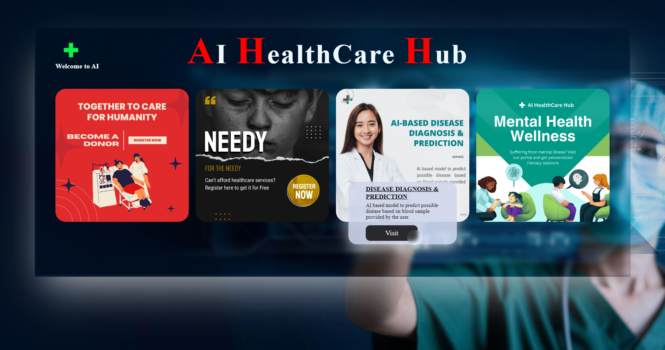

*(Fig. 7)*

Home page

Users can visit the Donor section, Needy Section, Diagnosis section and Mental Wellness section from the home page.

**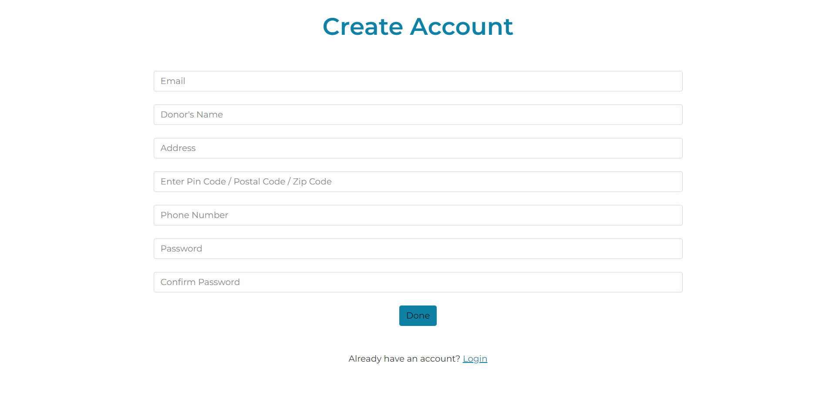***(Fig. 8)*

Donor registration page ( with location access )

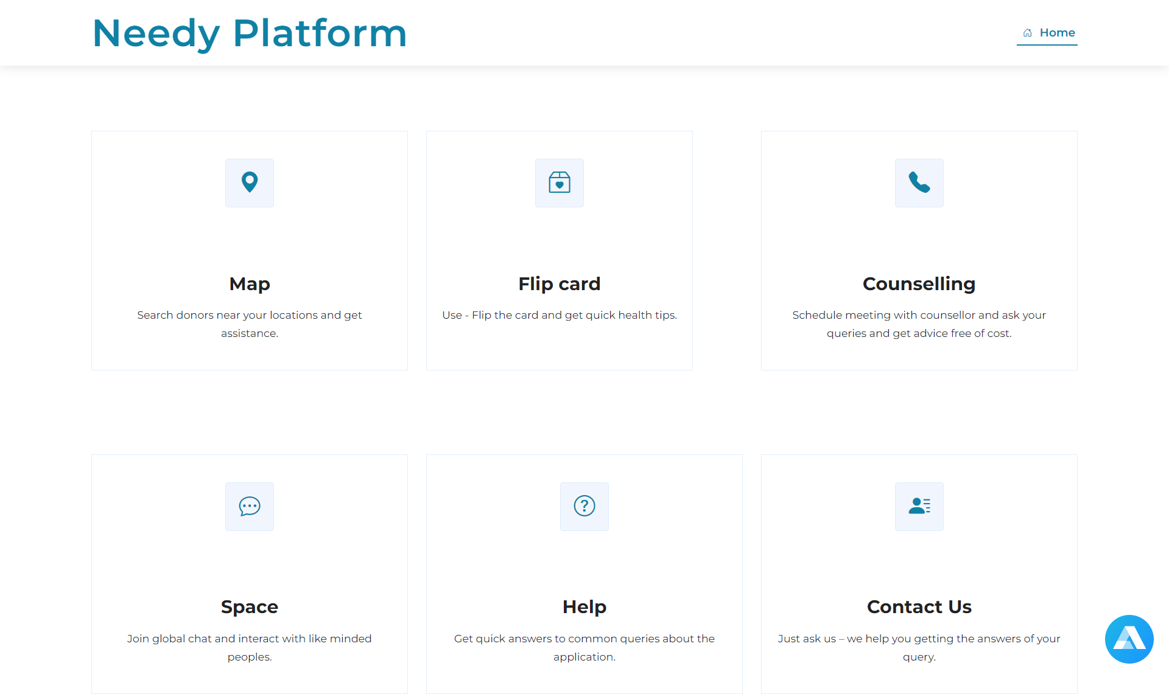(Fig. 9)

Needy Platform setup to find nearest donors and personalized counselling.

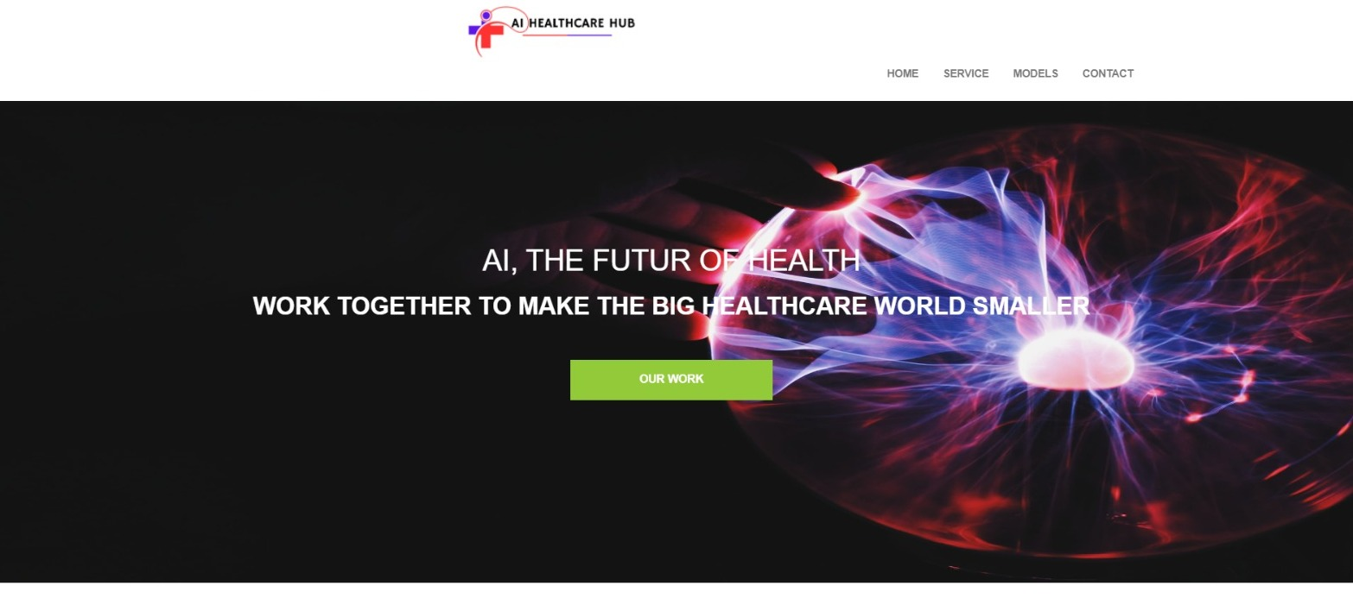

**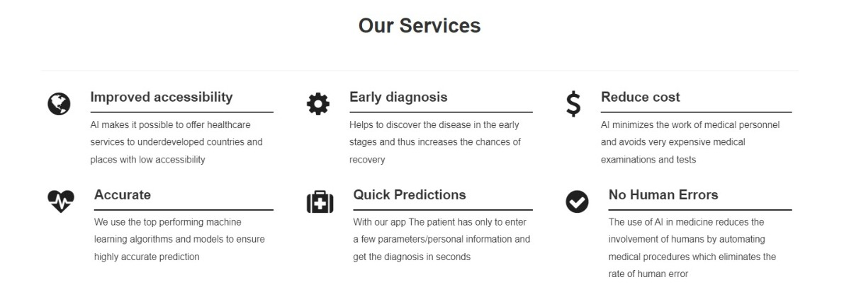***(Fig. 10)*

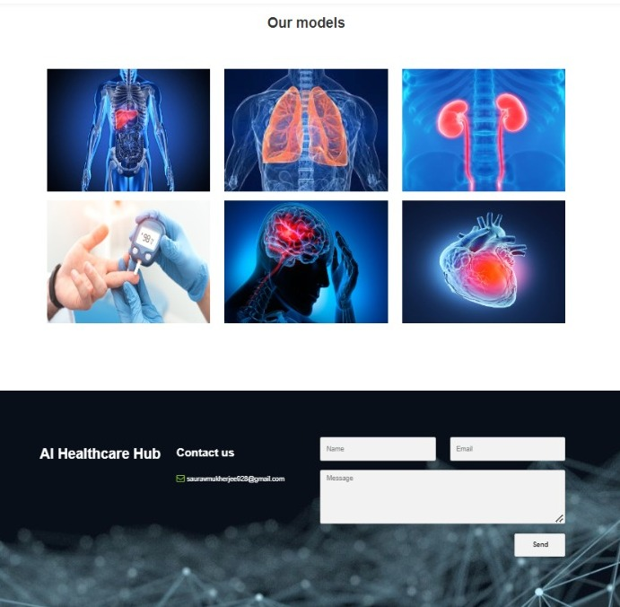  
*(Fig. 11)*

*Personalized Machine learning and Deep Learning Models to predict and diagnose Liver Disease, Heart Disease, Kidney Disease, Diabetes, Stroke Disease and Pneumonia Disease.*

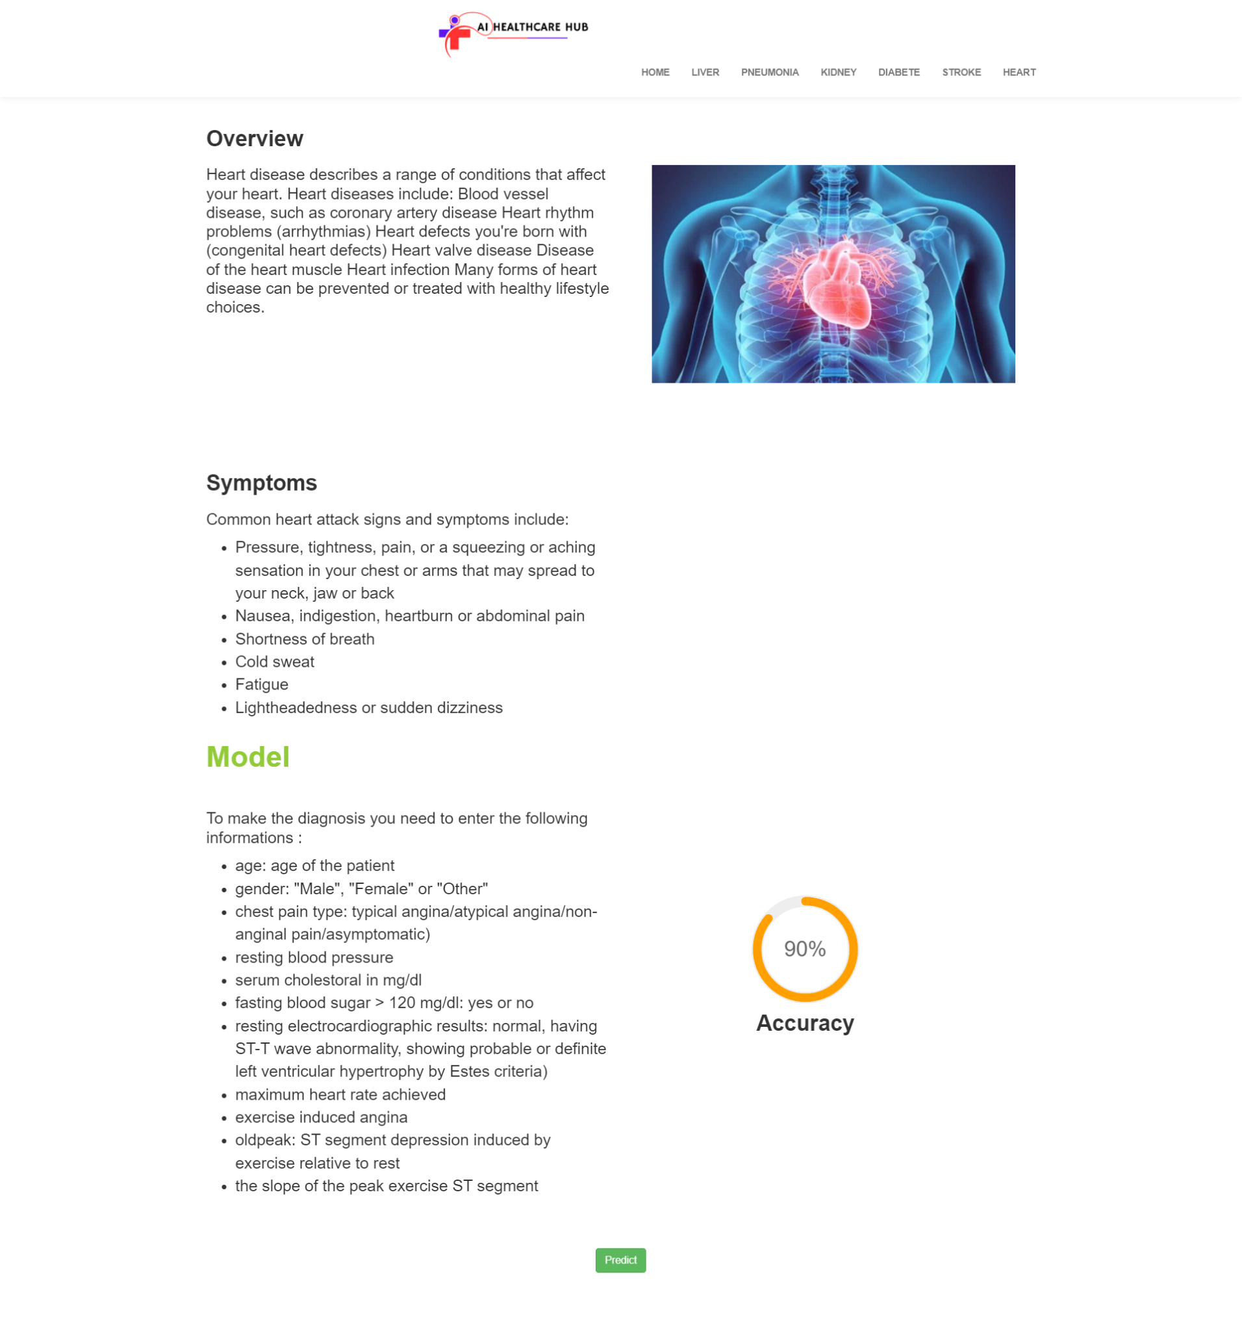  
*(Fig. 13)*

Models take input data from users blood samples, it uses some predefined parameters for the prediction of the disease. It shows positive or negative results based on accuracy of the model and dataset.

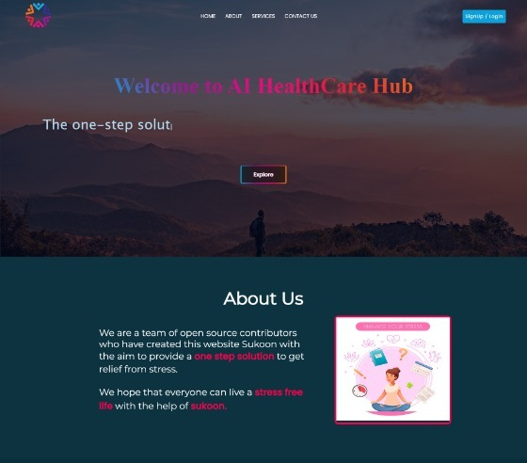  
*(Fig. 14)*

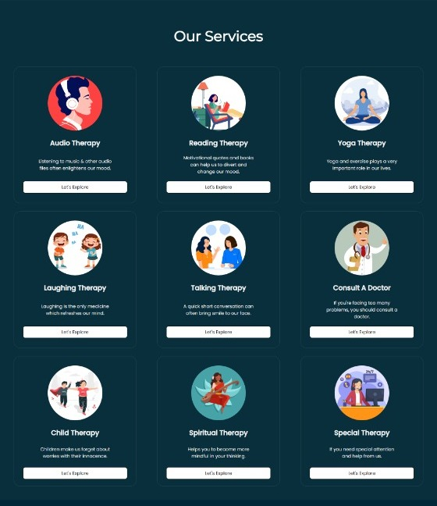  
*(Fig. 14)*

Mental wellness portal provides therapies on: Audio therapy, Reading, Laughing, yoga etc.

**5.2 Experimental results**

**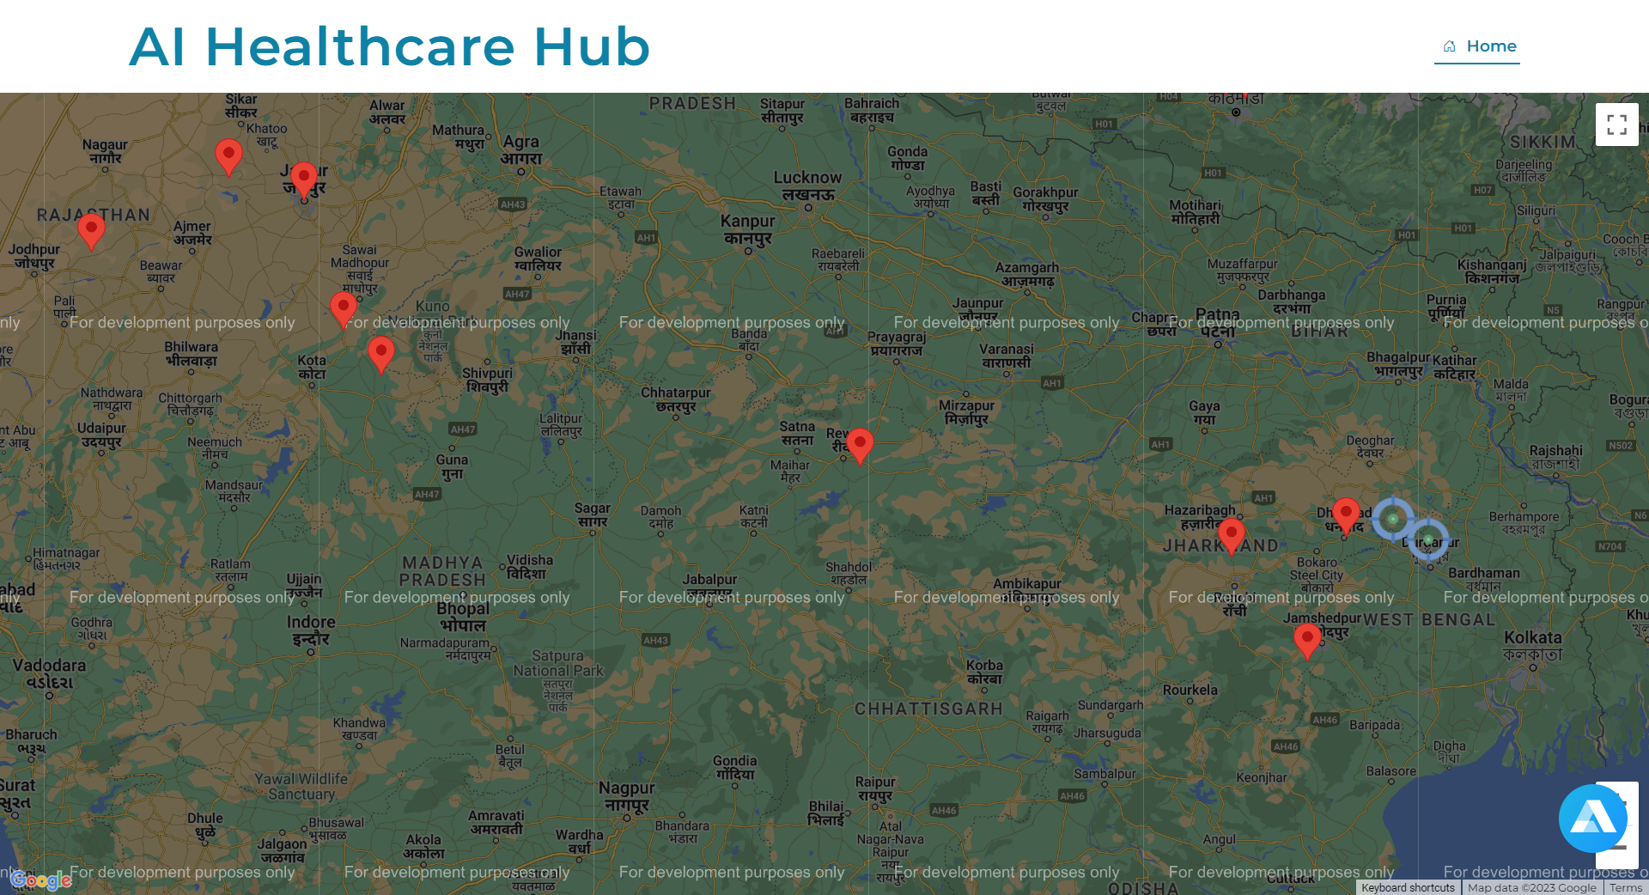***(Fig. 15)*

Experimental output data of nearest donors visited on the map ( seen by a user)

**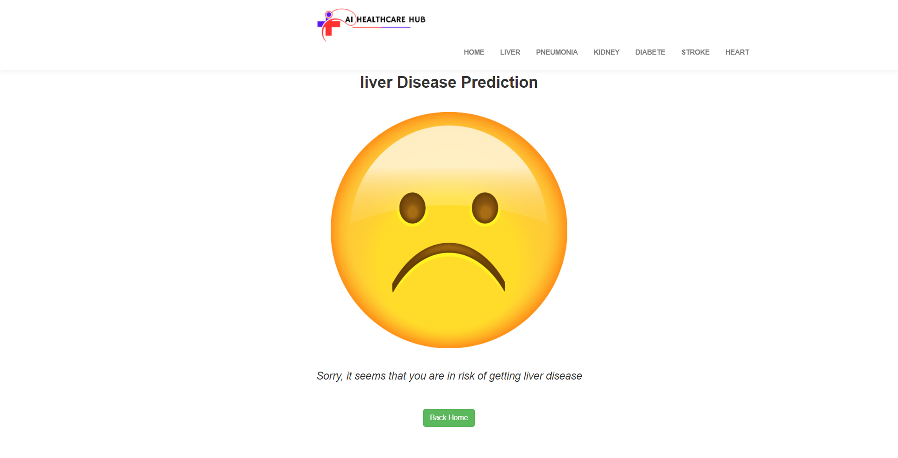***(Fig. 16)*

Disease prediction done by the machine learning model based on the blood sample parameters given by the user. ( e.g Positive liver disease found )

**6. Discussion and Conclusion:**

**6.1 Discussion**

Discussion of the proposed algorithms for the Smart AI-Healthcare Hub, focusing on their potential impact and limitations:

**Disease Diagnosis and Prediction**

The proposed machine learning and deep learning algorithms offer a promising approach to improving disease diagnosis and prediction. Machine learning algorithms like SVMs and KNN can effectively classify patients based on their clinical features, while deep learning algorithms like CNNs and RNNs can analyze complex data like medical images and longitudinal patient data to identify patterns indicative of specific diseases.

However, it is important to recognize the limitations of these algorithms. Machine learning algorithms may be susceptible to biases in the training data, which could lead to inaccurate or unfair predictions. Deep learning algorithms can be computationally expensive to train and deploy, and their performance may vary depending on the quality and quantity of the training data.

To address these limitations, ongoing research is focused on developing more robust and generalizable machine learning and deep learning models. Additionally, efforts are underway to improve data quality and collection procedures to minimize biases and ensure the accuracy of predictions.

**Mental Wellness**

The proposed recommendation algorithms have the potential to personalize mental wellness support for users. Content-based recommendation systems can tailor suggestions to the user's past preferences and needs, while collaborative filtering algorithms can provide recommendations based on the experiences of similar users.

However, these algorithms may not always capture the nuances of individual mental health needs. For instance, a user's mood or mental state may vary over time, and their preferences for mental wellness resources may change accordingly. Additionally, these algorithms may not be able to effectively recommend resources for less common or less well-known mental health conditions.

To address these limitations, further research is needed to develop more advanced recommendation algorithms that can better capture the complexities of mental health and provide more personalized and relevant suggestions.

**Donation and Needy Platform**

The proposed matching algorithms can efficiently connect donors with individuals or organizations seeking assistance. Greedy matching algorithms provide a quick and effective solution for immediate needs, while weighted matching algorithms consider multiple criteria to optimize the matching process for long-term sustainability. Reinforcement learning algorithms can dynamically adapt the matching strategies based on historical data and feedback, continuously improving the effectiveness of connections.

However, it is important to ensure that the matching process is fair and equitable, considering factors such as location, donation amount, and type of assistance needed. Additionally, the platform should consider the needs of both donors and recipients, ensuring that donations are used effectively and that recipients receive the support they require.

To address these limitations, ongoing research is focusing on developing more sophisticated matching algorithms that can better balance the needs of donors and recipients, while also considering factors like geographic proximity, language barriers, and cultural differences.

Overall, the proposed algorithms for the Smart AI-Healthcare Hub hold promise for improving healthcare outcomes and enhancing the overall patient experience. However, it is important to acknowledge the limitations of these algorithms and to continuously strive for improvement. By addressing these limitations and incorporating ethical considerations, the platform can achieve its full potential in improving the lives of individuals and communities.

**6.2 Future work:**

**1. Genomic Data Integration:**

Consider incorporating genomic data for more personalized disease prediction and treatment plans. Collaborate with genetic testing services to enhance the accuracy and depth of the disease prediction model.

**2. Continuous Improvement in Disease Prediction Models:**

Regularly update and improve disease prediction models based on the latest medical research and advancements in machine learning and data science.

**3. Global Expansion and Localization:**

Extend the reach of AI Healthcare Hub to a global audience, considering cultural and linguistic differences. Collaborate with healthcare professionals worldwide to tailor the platform to diverse healthcare needs.

**4. Enhanced Mental Wellness Resources:**

Expand the Sukoon platform by collaborating with mental health professionals, content creators, and experts to provide a more extensive range of resources. Include features like guided meditation, therapy chatbots, or virtual counseling sessions.

**5. User-Friendly Wearable Devices Integration:**

Collaborate with wearable device manufacturers to ensure seamless integration with a wider variety of devices. Enhance the platform's ability to interpret and analyze data from the latest wearables on the market**.**

**6. Blockchain for Healthcare Records:**

Extend the use of blockchain technology to secure and manage electronic health records (EHRs). Implement decentralized and secure systems for storing and sharing patient data with their consent.

**7. AI-Driven Drug Discovery and Treatment Plans:**

Explore the application of AI in drug discovery and treatment plan recommendations. Collaborate with pharmaceutical research institutions to leverage machine learning algorithms for personalized medication suggestions.

**8. Enhanced Telemedicine Features:**

Improve telemedicine features by integrating AI-driven diagnostic tools, virtual health assistants, and features that support remote monitoring of chronic conditions.

**6.3 Conclusion:**

In conclusion, the "AI Healthcare Hub" project presents a visionary and comprehensive approach to healthcare, leveraging cutting-edge technologies and artificial intelligence to address a spectrum of health-related challenges. The proposed model, with its focus on disease prediction, mental wellness, community engagement, and healthcare donations, reflects a commitment to holistic well-being.

**Key Takeaways:**

**Holistic Healthcare:**

AI Healthcare Hub recognizes that healthcare extends beyond disease management, encompassing mental wellness, community support, and proactive measures for a healthier lifestyle.

**Innovative Technologies:**

The integration of AI, machine learning, blockchain, and telemedicine showcases a commitment to leveraging the latest technologies to provide efficient, transparent, and user-centric healthcare solutions.

**User-Centric Design:**

Usability heuristics, continuous user testing, and a focus on user experience underscore AI Healthcare Hub commitment to providing a platform that is not only technologically advanced but also intuitive and user-friendly.

**Community Empowerment:**

The creation of a supportive community, facilitated by collaborative filtering and sentiment analysis, demonstrates an understanding of the power of shared experiences and knowledge in improving overall health outcomes.

**Ethical Considerations:**

The project recognizes the sensitivity of health data and emphasizes ethical considerations, privacy, and security. These foundational principles are crucial for building trust among users.

**References:**

Code : <https://github.com/SauravMukherjee44/AI-HealthCare-Hub>

Live website: <https://ai-healthcare-hub-saurav.netlify.app/>

"Artificial Intelligence in Healthcare: A Review and Outlook" by Zhiyong Zhang, Jinyu Zhang, and Qian Wang (2022):

<https://ieeexplore.ieee.org/document/9441741>

"Mindfulness-Based Interventions for Mental Health: A Review of the Evidence" by Danny Penman, Helen Hayes, and Mark Williams (2015)

<https://www.ncbi.nlm.nih.gov/pmc/articles/PMC5870875/>

"Social Interaction and Health: An Overview" by Lorraine Taylor, Karen Sefton, and Mike Wayman (2000)

<https://www.researchgate.net/journal/Social-Science-Medicine-1873-5347>